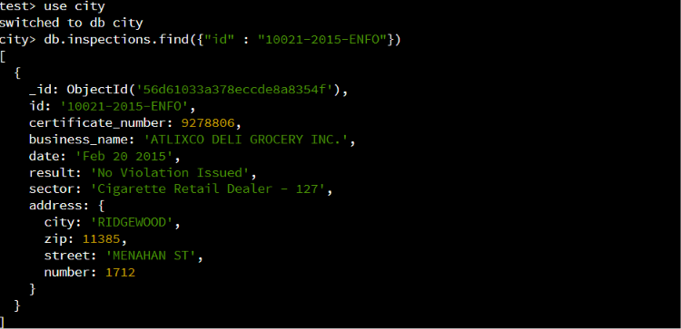
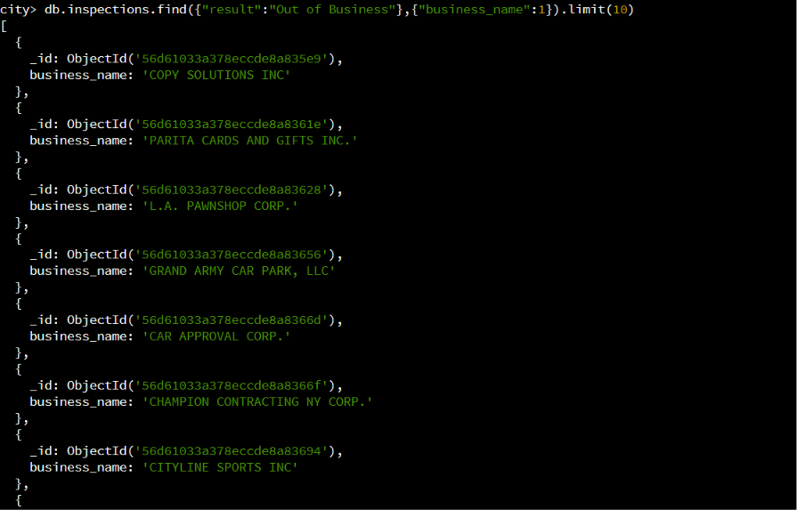
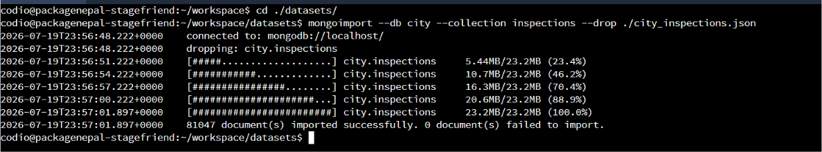
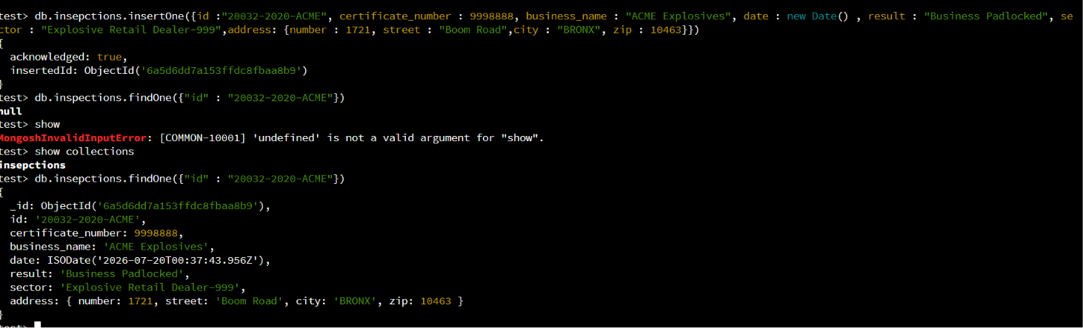
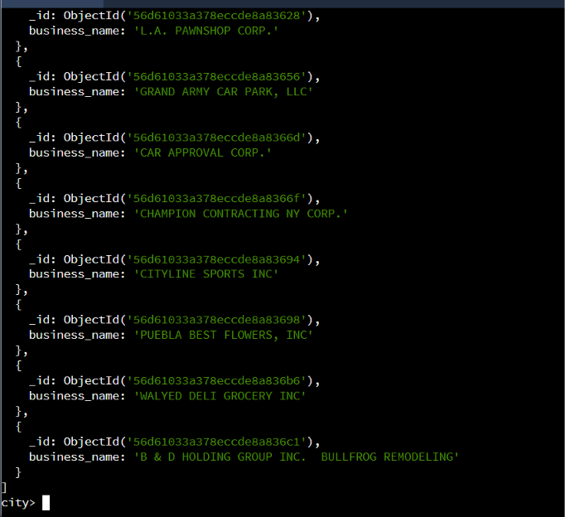
Amount of unique sectors: 87
Difference between the date type: my date utilized a time stamp while the others used regular date
Number of business with violation:
